Grading Students
Platform: HackerRank
Language: C
Module 2, Question 3

Problem Link
https://www.hackerrank.com/challenges/grading/problem

Problem Statement
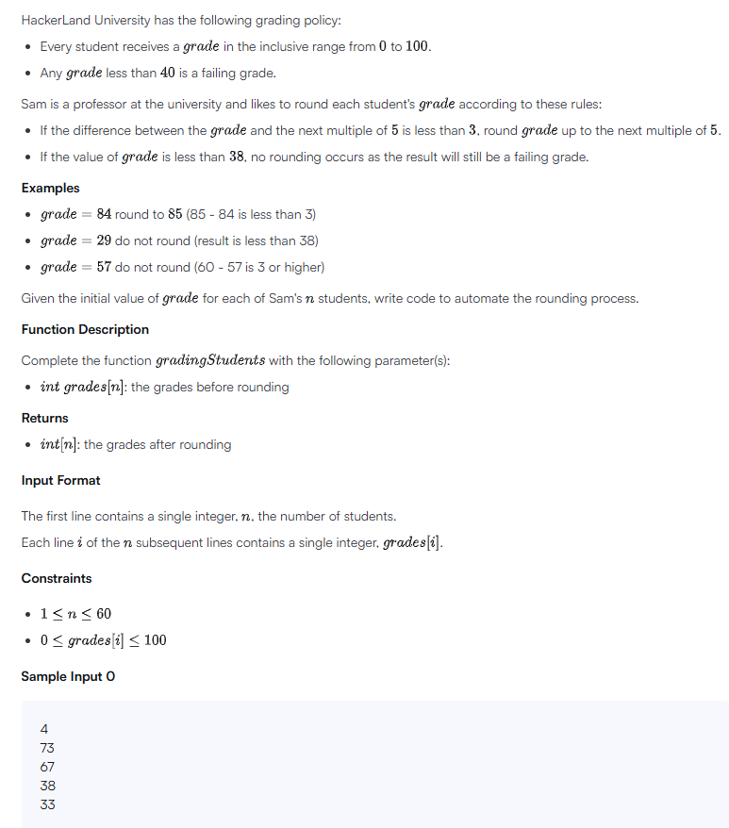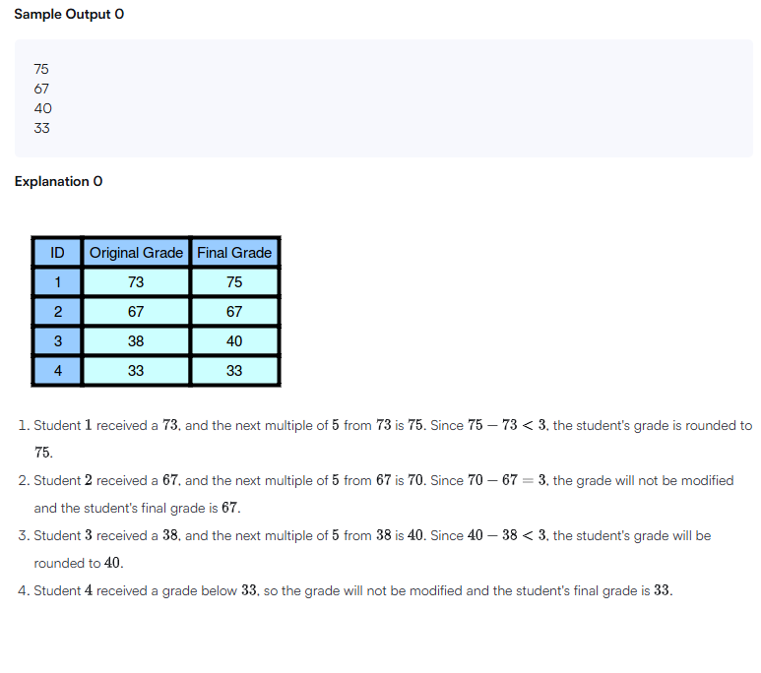

C Code
#include <stdio.h>
#include <stdlib.h>

int* gradingStudents(int grades_count, int* grades, int* result_count) {
*result_count = grades_count;
int *result = malloc(grades_count * sizeof(int));

for (int i = 0; i < grades_count; i++) {
int g = grades[i];
if (g >= 38 && g % 5 >= 3) {
g = g + (5 - g % 5);
}
result[i] = g;
}
return result;
}

int main() {
int n;
scanf("%d", &n);

int *grades = malloc(n * sizeof(int));
for (int i = 0; i < n; i++) {
scanf("%d", &grades[i]);
}

int result_count;
int *result = gradingStudents(n, grades, &result_count);

for (int i = 0; i < result_count; i++) {
printf("%d\n", result[i]);
}

free(grades);
free(result);
return 0;
}

Screenshot of Successful Submission



